Electronic Supplementary Material 3: Supplementary Information for Case Study 3

Summary Statistics for Case Study 3
Here, we give basic summary statistics for Case Study 3. Table 12 displays the sample size and percentage of observations in each category for the categorical variables. Missing values are denoted by an “Unknown” category.
Table 12
Summary Statistics for Case Study 3
Baseline characteristic
Baseline characteristic | n | %
Gender
Female | 9396 | 49
Male | 9092 | 47
Unknown | 565 | 3
Race
White non-Hispanic | 9064 | 48
Black non-Hispanic | 4606 | 24
Hispanic | 3535 | 19
Asian/Pacific Islander | 481 | 3
Other Race/Multi Racial | 112 | 1
American Indian/Alaskan Native | 35 | 0.5
Unknown | 1220 | 6
Grade Level
Middle School | 5930 | 31
High School | 13123 | 69
State
Texas | 5758 | 30
Kentucky | 5209 | 27
Louisiana | 2986 | 16
Michigan | 2449 | 13
Connecticut | 1027 | 5
Alabama | 849 | 4
New Jersey | 775 | 4
English as a Second Language
Yes | 290 | 2
No | 17182 | 90
Unknown | 1581 | 8
Gifted Education
Yes | 2351 | 12
No | 16492 | 87
Unknown | 210 | 1
Special Education
Yes | 1029 | 5
No | 17814 | 87
Unknown | 210 | 1
Free and Reduced Lunch
Yes | 8755 | 46
No | 6000 | 31
Unknown | 4298 | 23
Note. N = 19,053

Analysis of Adjusted Pair Score for Case Study 3

For this case study, the adjusted pair score has a mean of 0.50, a standard deviation of 0.294, and a correlation of 0.175 with the outcome of interest. Figure 5 displays a histogram of the adjusted pair score values. Table 13 displays the correlation of each covariate with our adjusted pair score. The correlation is highest for the pretest score; all other correlations are very small.

Figure 5: Histogram of Adjusted Pair Score for Case Study 3
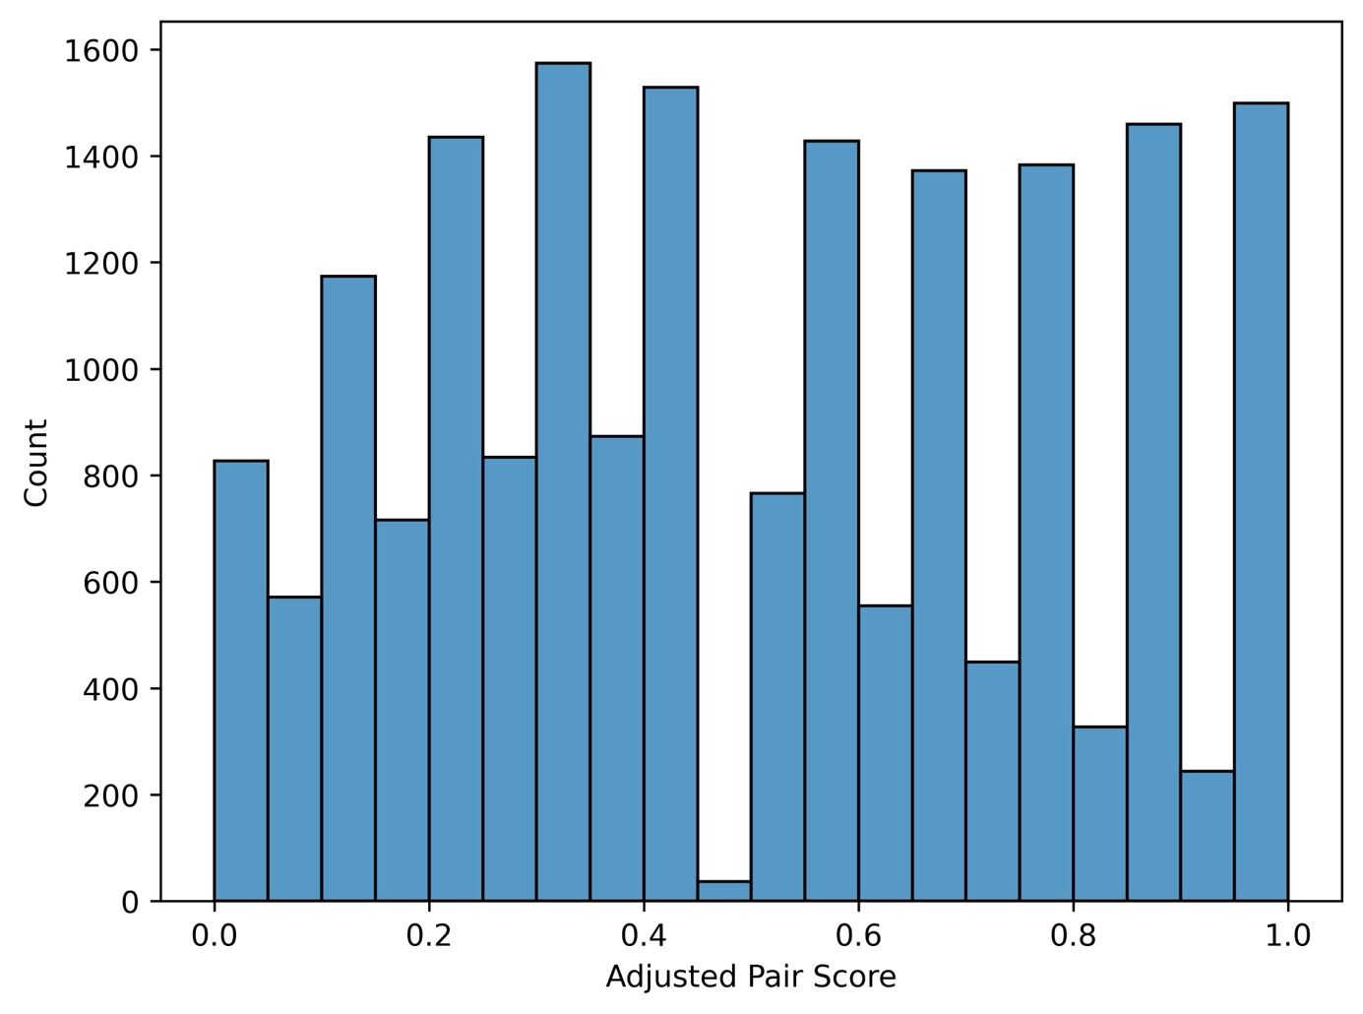
Table 13
Covariate Correlation with Adjusted Pair Score for Case Study 3
Covariate | Correlation with Adjusted Pair Score
Pretest Score | 0.481
Sex: Male | -0.021
Race: White non-Hispanic | 0.149
Race: Black non-Hispanic | -0.099
Race: Hispanic | -0.070
Race: Asian/Pacific Islander | -0.016
Race: Other Race/Multi-Racial | -0.006
Race: American Indian/Alaskan Native | -0.005
Grade Level: Middle School | -0.046
State: Texas | -0.198
State: Kentucky | 0.139
State: Louisiana | 0.085
State: Michigan | -0.047
State: Connecticut | 0.027
State: Alabama | 0.053
State: New Jersey | -0.019
Special Education | -0.134
Gifted Education | 0.070
English as a Second Language | -0.081
Free and Reduced Lunch | -0.002

Additional Results for Case Study 3
Table 14 compares a regression model with and without the adjusted pair score. As discussed in the paper, the adjusted pair score is statistically significant.

Table 14
Regression Results for Case Study 3
Variable | Baseline Model |  |  | LLM Model
Variable | Estimate | SE | p | Estimate | SE | p
Intercept | -0.290 | 0.122 | 0.019 | -0.368 | 0.123 | 0.003
Adjusted Pair Score |  |  |  | 0.153 | 0.028 | 0.000
OOB Predictions | 0.105 | 0.013 | 0.000 | 0.168 | 0.017 | 0.000
Pretest Score | 0.380 | 0.009 | 0.000 | 0.315 | 0.015 | 0.000
Pretest Score Unknown | -0.144 | 0.014 | 0.000 | -0.094 | 0.017 | 0.000
Male | 0.019 | 0.009 | 0.037 | 0.020 | 0.009 | 0.026
Gender Unknown | 0.026 | 0.037 | 0.488 | 0.021 | 0.037 | 0.567
White non-Hispanic | 0.045 | 0.104 | 0.663 | 0.039 | 0.103 | 0.704
Black non-Hispanic | -0.033 | 0.104 | 0.752 | -0.035 | 0.104 | 0.739
Hispanic | -0.045 | 0.105 | 0.667 | -0.048 | 0.105 | 0.643
Asian/Pacific Islander | 0.193 | 0.107 | 0.073 | 0.185 | 0.107 | 0.085
Other Race/Multi Racial | 0.010 | 0.119 | 0.933 | 0.007 | 0.119 | 0.953
Race Unknown | -0.027 | 0.107 | 0.803 | -0.030 | 0.107 | 0.782
Grade Level: Middle School | 0.477 | 0.054 | 0.000 | 0.482 | 0.054 | 0.000
English as a Second Language | 0.022 | 0.038 | 0.560 | 0.027 | 0.038 | 0.486
ESL Unknown | 0.099 | 0.021 | 0.000 | 0.096 | 0.021 | 0.000
Gifted Education | 0.106 | 0.017 | 0.000 | 0.101 | 0.017 | 0.000
Special Education | -0.136 | 0.021 | 0.000 | -0.118 | 0.021 | 0.000
Special Education Unknown | -0.220 | 0.062 | 0.000 | -0.208 | 0.062 | 0.001
Free and Reduced Lunch | -0.010 | 0.012 | 0.396 | -0.011 | 0.012 | 0.358
Free and Reduced Lunch Unknown | -0.076 | 0.017 | 0.000 | -0.077 | 0.017 | 0.000
Treatment | 0.005 | 0.054 | 0.993 | 0.007 | 0.054 | 0.902
Note. Regression models are fit as multilevel linear models using the ‘lmerTest’ package in R for p-values. Models have three levels: individuals are clustered within schools, and schools are clustered within states. The covariate capturing whether a student’s gifted education status is unknown is dropped as it correlates perfectly with ‘Special Education Unknown’.

Comparison to Ranking Based Indicator
A reviewer wondered if it was the ranking itself, based on pairwise comparisons, that is useful. Here, we do an experiment to investigate. For each pair, we replaced the LLM response with a comparison of the out of bag predictions from a random forest on the full dataset. Whichever student had the higher out of bag prediction was selected as the more likely student to score higher. We converted this into an adjusted pair score using the same method of processing as the LLM predictions. These random forest based adjusted pair scores would be equivalent to the LLM based adjusted pair scores if the LLM always picked the student with the higher out-of-bag prediction. Unlike the LLM based pair score, the random forest based adjusted pair scores—which are based on rankings—is not significant in the model. Table 15 displays the model results with this ranking-based pair score.
Table 15
Regression Results with Random Forest Ranking-Based Pair Score for Case Study 3
Variable | Baseline Model |  |  | LLM Model
Variable | Estimate | SE | p | Estimate | SE | p
Intercept | -0.290 | 0.122 | 0.019 | -0.295 | 0.123 | 0.017
Ranking Based Adjusted Pair Score |  |  |  | 0.011 | 0.014 | 0.428
OOB Predictions | 0.105 | 0.013 | 0.000 | 0.105 | 0.013 | 0.000
Pretest Score | 0.380 | 0.009 | 0.000 | 0.380 | 0.009 | 0.000
Pretest Score Unknown | -0.144 | 0.014 | 0.000 | -0.144 | 0.014 | 0.000
Male | 0.019 | 0.009 | 0.037 | 0.019 | 0.009 | 0.037
Gender Unknown | 0.026 | 0.037 | 0.488 | 0.026 | 0.037 | 0.483
White non-Hispanic | 0.045 | 0.104 | 0.663 | 0.045 | 0.104 | 0.664
Black non-Hispanic | -0.033 | 0.104 | 0.752 | -0.033 | 0.104 | 0.750
Hispanic | -0.045 | 0.105 | 0.667 | -0.045 | 0.105 | 0.665
Asian/Pacific Islander | 0.193 | 0.107 | 0.073 | 0.193 | 0.107 | 0.073
Other Race/Multi Racial | 0.010 | 0.119 | 0.933 | 0.010 | 0.119 | 0.935
Race Unknown | -0.027 | 0.107 | 0.803 | -0.027 | 0.107 | 0.800
Grade Level: Middle School | 0.477 | 0.054 | 0.000 | 0.477 | 0.054 | 0.000
English as a Second Language | 0.022 | 0.038 | 0.560 | 0.022 | 0.038 | 0.560
ESL Unknown | 0.099 | 0.021 | 0.000 | 0.099 | 0.021 | 0.000
Gifted Education | 0.106 | 0.017 | 0.000 | 0.106 | 0.017 | 0.000
Special Education | -0.136 | 0.021 | 0.000 | -0.136 | 0.021 | 0.000
Special Education Unknown | -0.220 | 0.062 | 0.000 | -0.220 | 0.062 | 0.000
Free and Reduced Lunch | -0.010 | 0.012 | 0.396 | -0.010 | 0.012 | 0.401
Free and Reduced Lunch Unknown | -0.076 | 0.017 | 0.000 | -0.076 | 0.017 | 0.000
Treatment | 0.005 | 0.054 | 0.993 | 0.005 | 0.054 | 0.933
Note. Regression models are fit as multilevel linear models using the ‘lmerTest’ package in R for p-values. Models have three levels: individuals are clustered within schools, and schools are clustered within states. The covariate capturing whether a student’s gifted education status is unknown is dropped as it correlates perfectly with ‘Special Education Unknown’.

